Starting Your Cat On A New Food
At Edgar and Ivy’s, we will most likely be feeding the cat you’ve adopted Hills Pet Nutrition Science Diet Cat Food (wet and soft). If you would like to switch your cat over to a different diet, we recommend following a specific protocol to avoid any gastrointestinal distress for your cat.
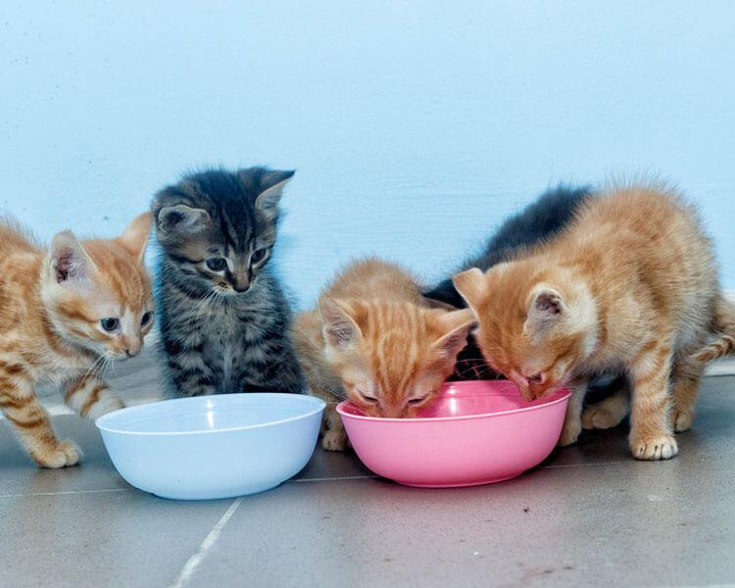

Basically, you’re going to integrate the new food into your cats’ diet a little bit at a time. Get the new food you’ll be feeding them (let’s say for example, Purina), and a small bag of the food they’ve been eating (Science Diet). Fill their bowl with 75% science diet, and about 25% of the Purina. Repeat for 3-5 days, then go ahead and do half Science diet, half Purina. Give this mixture another 3-5 days. Over time your cat will adjust to the ingredients in the new food and it will eventually be able to eat 100% of the Purina, or whatever other brand you choose.

>Make sure you’re feeding your cats a high protein diet— they are obligate carnivores and require a different diet than dogs, who require grain in their diets.

>Teach your cat to ration their treats. Obesity is a slippery slope, and it can cause severe health issues for your furry friend, just like it does in people!

>If you’re feeding your cat wet food on a regular basis, make sure they also have access to HARD, DRY food, as this helps clean the surface of their teeth. You don’t want your cat to end up with poor dental health.

