Declawing is NEVER THE ANSWER

At Edgar and Ivy’s, we hope to educate the public on the risks and complications that come along with declawing and ask that our adopters vow to NEVER declaw their cats!

Most people have heard of declawing cats, but the vast majority have no idea what this actually entails. Declawing is an inhumane and life threatening procedure that involves amputation at the first joint on each digit. To put this into perspective, imagine if you were to “declaw” a human; you would amputate the end of each finger, at the first joint, to eliminate any possibility of nail regrowth.
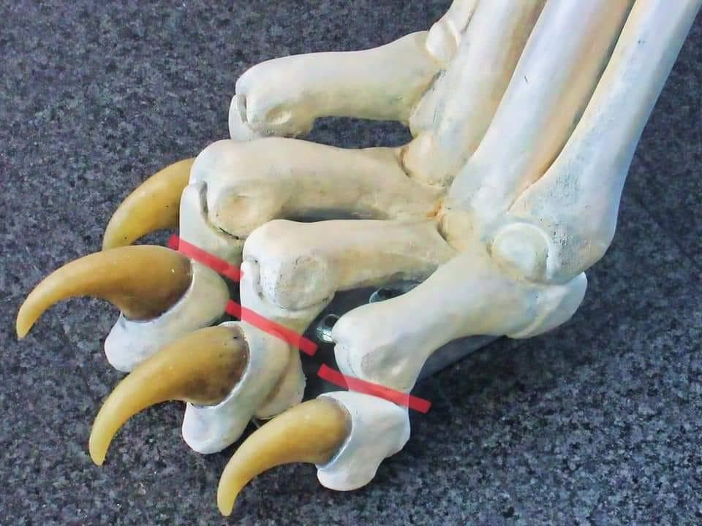

This photo shows exactly where each cut is made during the procedure; cats walk on their toes. By removing the ends of their toes, a cat must relearn how to walk, which is an incredibly painful and stressful experience. Many cats will develop new behavioral problems after being declawed, such as using the bathroom outside of the litterbox due to the coarse granules of litter being painful to walk on. The new exposed nerve endings will take months to heal, and have the possibility of causing life long pain. Attempting to walk without enduring high levels of pain and discomfort will make cats carry themselves in a way that can lead to early onset arthritis, which can be a costly issue to vet for. Cats who are declawed are also more likely to self isolate and become aggressive towards humans and other animals. In severe cases, your cat could develop an infection at the surgical site while attempting to heal, and need longterm medical care to aid the healing process. Not every cat will be able to fight off these infections and, in some cases, it can lead to an unnecessary death.

If you would like to learn about the alternatives to declawing that will help prevent unwanted scratching, read about it in our handout found under the “Information links and care sheets” tab on our website!

