WHAT KIND OF LITTER SHOULD I USE?

First off, buy the right litter box. Experts recommend using uncovered boxes with low, sloping sides so that your cat can enter and exit with ease. Enclosed litter boxes can end up becoming a hiding spot for your cat, and you don’t want them to hang out where they use the bathroom!

>First off, buy the right litter box. Experts recommend using uncovered boxes with low, sloping sides so that your cat can enter and exit with ease. Enclosed litter boxes can end up becoming a hiding spot for your cat, and you don’t want them to hang out where they use bathroom!

>Make sure to buy mats to place under your litter boxes so you can avoid having excess litter tracked around your house
>Ideally, you would have 1 litter box per cat, and 1 extra (so two cats would have 3 litter boxes to choose from).

>You should clean each box at LEAST once a day! Make sure you have a scoop that properly sifts the excess litter from your cats waste. Another route you can explore is a sifting litter box, which involves having a tray that will catch waste and sift the excess litter, and you simply empty the tray at each cleaning.

>We strongly recommend unscented litter (I know, I know). The chemicals used to make litter pleasant smelling to us can actually cause sinus issues and allergies for your cat.

>If you pick a clay litter, you’ll have two versions to pick from: clumping and non clumping. Typically, clumping litter makes the cleanup process faster and easier, especially when scooping by hand.

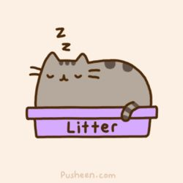
>There is also pine pellets, which is a great option for people who choose to use sifting litter boxes. The urine will dissolved the pellets leaving behind clumps, and the rest will stay on top. If your cat is sensitive to the dust from clay litters, pine pellets can alleviate a lot of issues like sneezing and allergies

